**BROOKFIELD TENNIS CLUB SUMMER CAMPS**

Tennis Coaching

Tournaments

Athletics

Tennis/Squash

Table Tennis

Prizes

Player of the Week

FUN FUN FUN

**30TH June – 4th July**

**11th – 15th August 2014.**

**Daily 10.00am to 1.00pm**

**Ages from 6 to 12 years old**

**Fee €95.00 for members**

**€100.00 for friends of**

**members**

**Qualified coaches and supervisors**

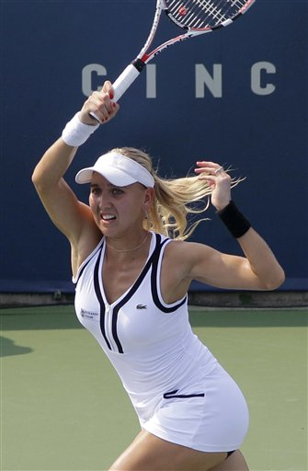

**Applications to:**

**Tadhg Lambe, Director of Tennis, Brookfield Tennis Club, Palmerston Park, Dublin 6**

“

**.”**

**APPLICATION FORM**

NAME……………………………………………...……

ADDRESS………………………………………………

………………………………………………………..…

DATE OF BIRTH………………………………….……

PARENTS NAME…………………….………………..

MOBILE NUMBER…………………………..…………

Week 1 30th June – 4th July €100 (members €95)

Week 2 11th – 15th August €100 (members €95)

Both Weeks (discount 10%) €190 (members €180)

Fee (payable to Tadhg Lambe and posted to Tadhg Lambe, Brookfield Tennis Club, Palmerston Park, Rathmines, Dublin 6 or dropped in club post box